
Sreenidhi Institute of Science and Technology
H.T No
Regulations:
A20
(An Autonomous Institution)
Code No: 8C262 Date: 22-Feb-2025 (FN)

B.Tech I-Year II- Semester External Examination, February - 2025 (Supplementary)
COMPREHENSIVE VIVA TEST - II (ECE)

Time: 3:00 Hours Max.Marks:70
Note: Answer Any 70 Questions.
Student can solve more than 70 questions, but maximum 70 marks will be awarded.
Calculator's are not allowed.

S.No | Question
1. | If 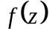 is analytic function in the entire z-plane and bounded everywhere, than A) 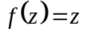 B)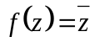 C) 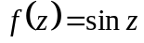 D) 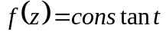
2. | If is analytic in domain D, then is  A). Continuous in D C). Continuous but not necessary differentiable in D  B). Neither Continuous nor differentiable in D D). differentiable in D
3. | A vector field which has a vanishing divergence is called A. Rotational field B. Solenoidal field C. Irrotational field D. None of the above
4. | If =log z, then a) Satisfies Cauchy Riemann Equation b) is analytic  c) is not analytic d) none of the above
5. | The value of integral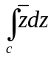,where C is the shortest path joining A(0,0) to B(1,1) is A)1 B)2 C)I D)0
6. | The value of the integral 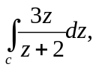where 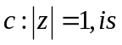 A)1 B)2 C)3 D)0
7. | Let C be a circle 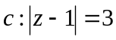 in the complex plane, then 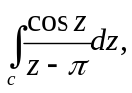is ______. A)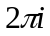 B) 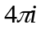 C) 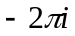 D)none of these
8. | As per cauchy’s integral formula 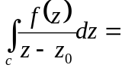 a)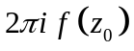 b) c) 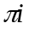 d) 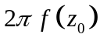
9. | The value of 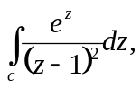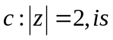__________ A) 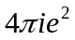 B) 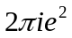 C) 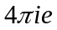 D) 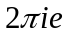
10. | Let C be a circle 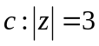in the complex plan and 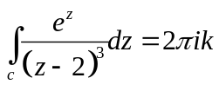then k=____. A) 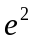 B) 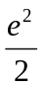 C) 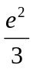 d)None of these
11. | The sections cut by a plane on a right circular cone are called as ______  A) Parabolic sections B) Conic sections C) Elliptical sections D) Hyperbolic sections
12. | In conics, the _____ is revolving to form two anti-parallel cones joined at the apex.  A) Ellipse B) Circle C) Generator D) Parabola
13. | Which of the has an eccentricity more than unity?  A) Parabola B) Circle C) Hyperbola D) Ellipse
14. | __________ is a curve generated by a point on the circumference of a circle which rolls without slipping on a straight line.  A) Trochoid B) Epicycloid C) Cycloid D) Evolute
15. | Representative fraction is the ____________________  A) ratio of the length in drawing to the actual length C) reciprocal of actual length B) ratio of the actual length to the length in drawing D) square of the length in drawing
16. | The planes which are perpendicular to both the reference plane (horizontal and vertical) are visible clearly only if we watched from ___________  A) front view B) top view C) side view D) isometric view
17. | An equilateral triangle of side 10 cm is held parallel to horizontal plane and base is parallel to xy reference line. The length of line from front view will be _____  A) 8.66 cm B) 10 cm C) 0 cm D) 12.47 cm
18. | To understand some of the hidden geometry of components an imaginary plane is used to cut the object which is called _____________  A) auxiliary plane B) picture plane C) section plane D) additional plane
19. | To find the true shape of the section, it must be projected on a plane parallel to the _____________  A) Profile plane B) Vertical plane C) Auxiliary plane D) Section plane
20. | The angle between the isometric axes is __________  A) 180 degrees B) 60 degrees C) 90 degrees D) 120 degree
21. | The value of the ratio of isometric length to true length is ________  A) 0.141 B) 0.372 C) 0.815 D) 0.642
22. | The length in isometric drawing of line is 20 cm. What is the true length of it?  A) 24.53 cm B) 15.46 cm C) 19.31 cm D) 23.09 cm
23. | Front view of the square is given and has to draw its isometric view which angle the base has to make with horizontal?  A) 90 degrees B) 15 degrees C) 30 degrees D) 60 degrees
24. | Ideal voltage source has _______  A) Zero internal resistance B) infinite resistance C) low value of current D) large value of emf
25. | Nodal analysis is based on _________  A) KCL B) KVL C) Both D) law of conservation of energy
26. | The circuit having same properties in either direction is known as ___circuit  A) lumped B) unilateral C) Bilateral D) reversible
27. | The graph of a network has 8 nodes and 5 independent loops. The number of branches of graph is ____  A) 11 B) 12 C) 13 D) 14
28. | The no ‘of independent loops for a network with ‘n’ nodes & ‘b’ branches is  A) n-1 B) b-n C) b-n+1 D) b+n-1
29. | A 2cm long coil has 10turns and carries a current of 750mA. The magnetising force of the coil is  A) 225AT/m B) 675AT/m C) 470AT/m D) 375AT/m
30. | The reciprocal of reluctance is _________ A) susceptibility B) permeability C) permeance D) Reluctivity
31. | The ratio of maximum value to R.M.S value is known as A) Form factor B) Peak factor C) Zero factor D) UPF
32. | The ratio of R.M.S value to Average value is known as  A) Form factor B) Peak factor C) Zero factor D) UPF
33. | In steady state conditions inductor acts as A) UPF B) LPF C) Short circuit D) Open circuit
34. | In steady state conditions Capacitor acts as  A) LPF B) Short circuit C) UPF D) Open circuit
35. | Superposition theorem is not applicable to  A) Nonlinear elements B) transformers C) port networks D) Dependent sources
36. | Reciprocity theorem is valid to  A) Linear elements B) Single source circuits C) Diodes D) Transformers
37. | The value of resistance R shown in below figure is __________  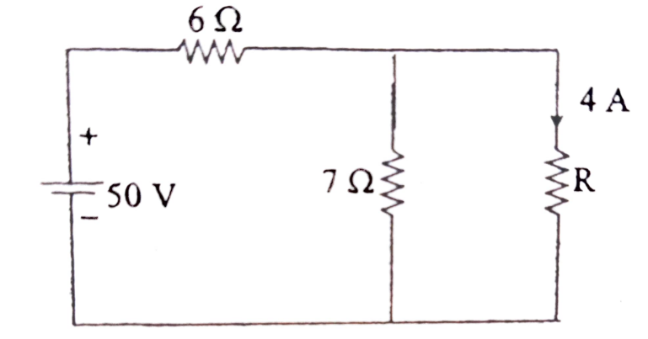  A) 3.5Ω B) 2.5Ω C) 1Ω D) 4.5Ω
38. | What is the need for a circular queue?  A) effective usage of memory B) easier computations  C) to delete elements based on priority D) implement LIFO principle in queues
39. | A normal queue, if implemented using an array of size MAX_SIZE, gets full when  A) Rear=MAX_SIZE-1 B) Front=(rear+1)mod MAX_SIZE  C) Front=rear+1 D) Rear=front
40. | In linked list implementation of a queue, where does a new element be inserted?  A) At the head of link list B) At the tail of the link list  C) At the centre position in the link list D) None
41. | In linked list implementation of a queue, front and rear pointers are tracked. which of these pointers will change during an insertion into EMPTY queue?  A) only front pointer B) only rear pointer  C) Both front and rear pointer D) No pointer will be changed
42. | Breadth First Search is equivalent to which of the traversal in the Binary Trees?  A) Pre-order Traversal B) Post-order Traversal  C) Level-order Traversal D) In-order Traversal
43. | A Binary Tree can have  A) Can have 2 children B) Can have 1 children  C) Can have 0 children D) All
44. | Which of the following algorithm does not divide the list?  A) Linear search B) Binary search C) Merge sort D) Quick sort
45. | If several elements are competing for the same bucket in the hash table, what is it called?  A) Diffusion B) Replication C) Collision D) Duplication
46. | What will happen if a class is not having any name?  A) It cannot have a destructor. B) It cannot have a constructor.  C) It is not allowed. D) Both a and b.
47. | Object based language differs from object oriented language as it does not support features _____ .  A).Encapsulation B) Inheritance C) Abstraction D) Polymorphism
48. | Which keyword is used to declare the friend function?  A) firend B) friend C) classfriend D) myfriend
49. | What is Operator overloading in C++ ?  A) giving new meaning to existing c++ operators B) making c++ operators work with objects  C) giving c++ operators more than they can handle D) making new c++ operators
50. | What is Inheritance in C++?  A) Wrapping of data into a single class B) Deriving new classes from existing classes  C) Overloading of classes D) Classes with same names
51. | Which of the below given guideline is incorrect for Effective Writing skill  A. Use of difficult words B. Use of appropriate words  C. Avoid using jargon D. Avoid technical words
52. | Chose the correct word with no redundancy  A. Close proximity B. Join together C. Four hours D. Period of time
53. | Let’s open the door is …………. type of sentence  A. Imperative B. Declarative C. Exclamatory D. Interrogative
54. | Complete the following statement: A well‐written paragraph should ________  A. Focus on a single, coherent idea. B. Consist of logically connected sentences.  C. Both a and b D. None.
55. | Which statement about paragraph length is TRUE?  A. written dialogue starts a new paragraph with each new speaker.  B. Use short paragraphs when you are analyzing complex ideas or data.  C. Use long paragraphs when you are presenting facts in a technical manual.  D. None.
56. | The smooth, logical flow of sentences within a paragraph is called ________paragraph deduction.  A. paragraph deduction B. paragraph coherence. C. paragraph personality D. None
57. | A reader should be concerned mainly with four factors while receiving and interpreting any text:  A .Ideation, Encoding, Transmission, and Decoding  B. Encoding, Transmission, Decoding, and Response  C. Decoding, Comprehending, Text Analysis, and Response  D. Decoding, Determining, Critical Examination, and Feedback
58. | Which of the following can be considered as Active Reading?  a) The reader pays attention to either content or style.  b) The reader differentiates between ideas, opinions, feelings, and facts.  c) The reader does not interpret the graphics.  d) The reader gives more importance to the literal meaning of the text.
59. | What skill is essential for the critical and evaluative understanding of a text?  A. Skimming and Scanning B. Literal Comprehension  C. Text Analysis D. Scanning and Overview
60. | A -------------- is written for a clear purpose and to a particular audience. Specific information and evidence are presented, analyzed and applied to a particular problem or issue.  A. Letter B. Paragraph C. Report D. Passage
61. | Annual reports and progress reports are few examples of -------------- reports.  A. Vertical B. Periodic C. Informational D. None.
62. | ---------------- is a model of Vertical or Lateral report.  A. F.I.R B. A management report C. A financial report D. None
63. | A resume that focuses more on skills you have acquired rather than listing of positions you have held is……………. Resume  A. Combination. B. Chronological. C. Formal. D. Functional.
64. | What is the total number of references normally given in a CV?  A. Two B. Three C. Four D. Five.
65. | Which of the following is not revealed in a bio-data?  A. Career aim B. Address C. Name D. References.
66. | ....... evaluates the research method used and holds that information in retrospect to analysis and critique. A. Journal article review B. Research article review C. Science article review D. None.
67. | The component of an attitude that refers to the thoughts and beliefs one has about an attitude object is called …………..  A. Affective component B. Behavioral component C. Cognitive component D. None.
68. | Positive frame of mind can help you in  A.The fear of failure and making mistakes C. Self-defeating talk  B. Gives you the strength not to give up and encounter obstacles on your way. D. None
69. | When an electron is accelerated by potential difference of V volts, the deBroglie wavelength is given by  A. nm B. Aº C. D. A⁰
70. | Existence of matter wave was experimentally first demonstrated by A. Newton B. Planck C. Davisson and Germer D.de-Broglie
71. | Order of thickness of the gold foil in G.P Thomson experiment is A.1nm B. 1A.U C. 10 A.U D. 1µm
72. | Dielectrics are  A. Super conductors B. Electric insulators C. Materials that work under low voltages D. None of the above
73. | Choose the correct relation  A). E= ԑ₀( ԑ_{r}-1)P B). D= ԑ₀( ԑ_{r}-1)E C). P= ԑ₀( ԑ_{r}-1)E D). ԑ_{r}=(χ-1)
74. | The polarization that is affected by temperature is  A. Dipolar polarization B. Electronic polarization  C. Ionic polarization D. None of the above
75. | Coherence of light is measured from A. Variation in spot size with distance B. visibility of interference fringes it produces C. brightness of the beam D. wavelength of the beam
76. | Propagation of light through fiber core is due to  A. diffraction B. interference C. total internal reflection D. refraction
77. | The process of mixing the signal with carrier is called  A. dispersion B. attenuation C. modulation D. de modulation
78. | To overcome the problem of inter model dispersion one has to use A. Multimode fiber B. step index fiber C. graded index fiber D. plastic fiber
79. | One Bohr magneton is equal to A.9.27 x 10⁻²⁴ amp-meter² B. 9.1 x 10⁻³¹ amp-meter²  C. 9.27 x 10⁻¹⁶ amp-meter² D. 9.1 x 10⁻²⁴ amp-meter²
80. | Pn junction diode cannot be used  A. as a rectifier B. for increasing the amplitude of an ac signal  C. for getting light radiation D. for converting light energy to electrical energy
81. | Nanomaterials exhibit  A. super plasticity B. superconductivity C. semiconducting properties D. all of the above
82. | Sol gel technique in nanotechnology is used for  A. identification of nanoparticles B. characterization of nanoparticles  C. synthesis of nanoparticles D. determination of the size of nanoparticles
83. | The size limitations of the nanomaterilas are in the range of  A.100 to 1000 nm B. 1 to 100 nm C. 10000 to 100000 nm D. 1000 to 10000 nm
84. | For detecting light intensity we use  A. photodiode in reverse bias B. photo diode in forward bias  C. LED in reverse bias D.LED in forward bias
85. | The Fermi level of an n-type semiconductor  A. Lies mid way valance band and conduction band B. Lies towards the conduction band C. Lies towards the valancy band D. Does not exist
86. | The region between the lower critical field and upper critical field is called  A. Super conducting state B. space charge region C. normal state D. vortex region  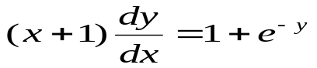
87. | The solution of is  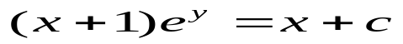A. B. 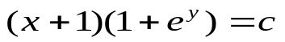  C.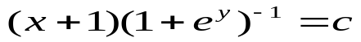 D.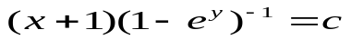
88. | The differential equation 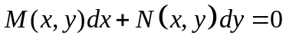is an exact equation if  a)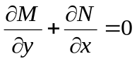 b)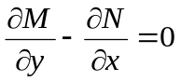  c)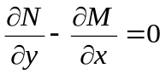 d)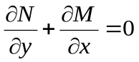
89. | The integrating factor of 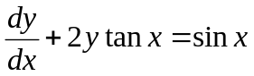is A. cos²x B. sec²x C. sin²x D. cosec²x
90. | If the rate of growth is proportional to the amount x of the substance present and if 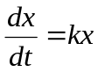then x is equal to  A).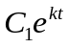 B). 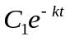 C). 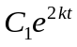 D).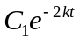
91. | The particular integral of 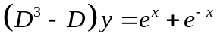, is  A. 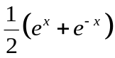 B.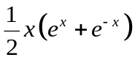  C. 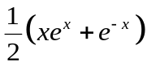 D. 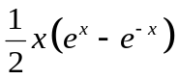
92. | . 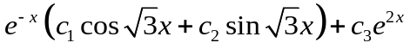, is the general solution of  A. 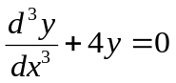 B. 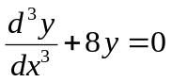  C. 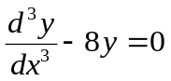 D. 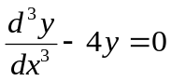
93. | The value of 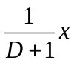 A. x B. x+1 C. x – 1 D. x²/2
94. | A). 2 B) 1 C) -1 D) -2
95. | 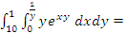  A) 9(1-e) B) 8(1-e) C) 9(e-1) D) 8(e-1)
96. | Area bounded by the y-axis, the line y=2x and the line y=4 is ____  A) 8 B) 6 C) 4 D) 2
97. | The valve of 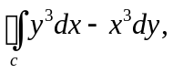where c is a circle of radius 2 centered in the origin A) 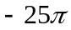 B) 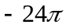 C) 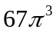 D) 87
98. | The valve of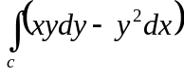, where c is the square cut from the first quadrant by the lines x=1 and y=1 A) 1 B) 1/2 C) 3/2 D) 5/2
99. | The Value of 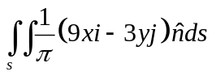over the sphere given by 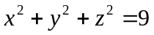is  A) 216 B) 218 C) 220 D) 300
100. | For a scalar function , the directional derivative at the point P(1, 2, -1) in the direction of the vector is  A.-18 B. 18 C. D.

-- 00 -- 00 –

